California Department of Insurance (CDI)
Frequently Asked Questions for Whole Dollar Tax Reporting for Surplus Line Brokers (Updated 1/22/2024)
- Do we round up to the next whole dollar or do we round to the nearest whole dollar up or down depending on the amount?
- When reporting amounts in whole dollar, tax filers are to disregard the fractional part of a dollar, unless it amounts to fifty cents ($0.50) or more, in which case it shall be increased to one dollar ($1.00).
- For the 2023 Tax Return: Report in Whole Dollars for Lines 1-3, 5, 8, and 9. Pay the amount due as reported.
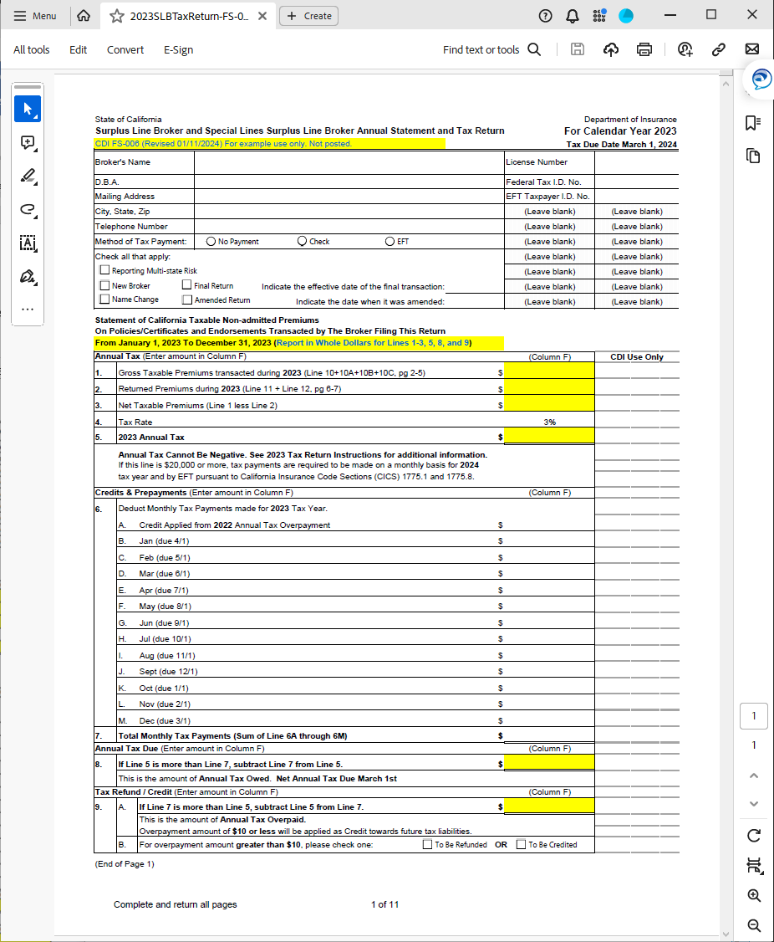

- For the Monthly Tax Payment Voucher: Report in Whole Dollars for Lines 1-3, 5, 6, and 7. Pay the amount due as reported.

- Is there a bulletin about this change?
Notice of Whole Dollar Reporting is provided in the 2023 Tax Form instructions. Additional clarifying information will be posted on the CDI Tax Page when available.

- When does/did this go into effect?
Whole Dollar Reporting goes into effect for reporting the 2023 Annual Tax due March 1st, 2024, for surplus line brokers.

- Is this only if mailing by check or does this apply to Electronic Funds Transfer (EFT) payments as well?
Whole Dollar Reporting applies to all methods for tax payments only. (Note: Assessments must be paid in full exact amount and sent to the appropriate mailing address as provided in the assessment letter.)

- Is there a grace period on this change?
CDI will still accept your tax payment if cents were already reported/included/paid. For your next tax payment, please report/pay the tax in whole dollar.
• For the 2023 Tax Return: Report in Whole Dollars for Lines 1-3, 5, 8, and 9. Pay the amount due as reported.
• For the Monthly Tax Payment Voucher: Report in Whole Dollars for Lines 1-3, 5, 6, and 7. Pay the amount due as reported.
• If you already paid tax including cents, please report the cents on the tax return and/or voucher. For your next tax payment, please report/pay the tax in whole dollar.

- What happens if a payment is sent in or paid via Electronic Funds Transfer (EFT) with the cents included?
Please see item 5 above.

- We don’t need to round the premium amount correct?
Please see items 1 and 5 above.

- Do we round Stamping fees?
No. Whole Dollar Reporting applies only to Tax Forms filed with California Department of Insurance. This does not apply to Stamping fees which are collected by the Surplus Line Association of California.

