June 12, 2020

Commissioner Ricardo Lara
California Department of Insurance
300 Capital Mall, 17th Floor
Sacramento, CA 95814

Re: Bulletin 2020-3 – Premium Refunds, Credits, and Reductions in Response to COVID-19 Pandemic
Insurer: GuideOne Mutual Insurance Company
GuideOne Specialty Mutual Insurance Company
GuideOne National Insurance Company
NAIC: 303-15032
303-14559
303-14167

Dear Commissioner Lara:

GuideOne Insurance continues to recognize the unprecedented nature of the events surrounding COVID-19 and the impact to the people of California. To ensure we provide appropriate accommodations to our policyholders through these difficult times, we instituted a 60 day grace period on cancellations due to non-payment of premium on a countrywide basis through July 2020. In addition, did not assess late fees or non-sufficient funds fees during this grace period. GuideOne continues to work with our insureds to ensure we are flexible during these unique times. We continue to accept individual requests for those that have suffered a hardship as a result of COVID-19 and offer flexibility and options regarding premium payments.

GuideOne analyzed the book of business in 2020 to determine the overall impact to our customers and the exposures insured due to the events surrounding Covid19. It was determined that an overall premium reduction would not address this appropriately, and chose to assess any reduced exposures and corresponding premium adjustments on an account by account basis. Given the nature of commercial business and the variance in what is considered “essential business” in the state, we believe this continues to be the appropriate course of action.

GuideOne is a niche insurance carrier with our primary niche focus being Religious Organizations, Education, Non-Profit and Human Services and Senior Living Communities. Given the focus of these niches, the vast majority of our insureds continue to be considered “essential workers”. We have continued to respond to individual risk situations to adjust premiums, amend exposure basis as well as review coverage needs.

In accordance with Bulletin 2020-3, we have provided the below information identifying by line of business.

Commercial Automobile
GuideOne continues to offer insured’s who have ceased the use of their vehicles during the COVID-19 pandemic, the opportunity to suspend their auto coverage. The insured is prorated the return premium for the period of suspension. This would ensure that our insureds recognize the full benefit of their reduced exposure by pro-rating the entirety of their premium for the suspended coverage.
Rather than providing a blanket credit or premium reduction to all insureds, we believe this is the most appropriate action as it addresses the true reduction of exposure while allowing flexibility to our insureds to halt coverage for vehicles not operated during the state’s emergency order.
In addition to our Core Business niches, we write two additional programs. The vast majority of this premium falls in our Oil & Gas Fuel Haulers program. Given the essential nature of this business and their continued operations throughout COVID-19, no premium adjustment is necessary at this time. However, we are offering the option of auto suspensions as well, should any vehicles be out of service.
Finally, given our niche focus and the industry segments we serve, our filed rating plan already contemplates a reduced usage based on the nature of our insureds. Below is a representation of our current Loss Cost, LCM and Rate in relation to ISO. This is consistent across the territories within the state of California and with both School/Church buses and Private Passenger Autos.
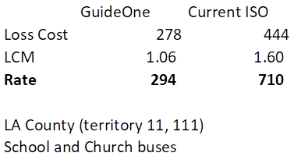
We will continue to work with our insureds on a case by case basis who have seen a significant impact due to COVID-19 and their auto usage.
Workers’ Compensation
A large portion of the GuideOne Workers’ Compensation book of business is in the Senior Living Community space. With the passing of Governor Gavin Newsom’s Executive Order N-62-60, which created a rebuttable presumption that an employee’s COVID-19-related illness arose out of the course of employment for purposes of obtaining workers’ compensation benefits, we believe there has been a potentially significant increase in exposure that was not contemplated in our filed rating plan. As 2020 evolved and as expected, and with the niche markets we serve, we did experience increase in new claims in 2020.
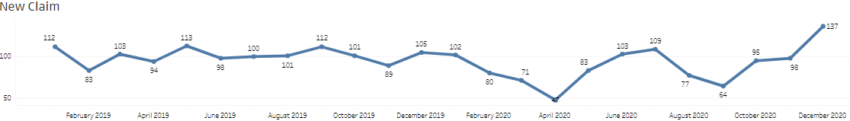
GuideOne workers’ compensation business is subject to premium audit to reflect accurate payroll and exposure for the policy period. We have also adopted and implemented the WCIRB changes addressing telecommuter classifications and payroll exclusion rule effective 7/1/2020.
As noted above, GuideOne instituted a 60-day countrywide grace period for premium payments in which we will not assess late fees or cancel for non-payment. Given the guidance following a meeting between APCIA staff and Deputy Commissioner Ken Allen in 2020, we will address any premium reduction through the annual audit process as we have already provided premium accommodations through the application of a grace period.
Commercial Multiple Peril
Commercial Property – GuideOne does not see reduction in loss exposure as it relates to commercial property. As shown below, the causes of loss shown from 2010-2019 continue to be exposures we anticipated would continue to exist throughout 2020. 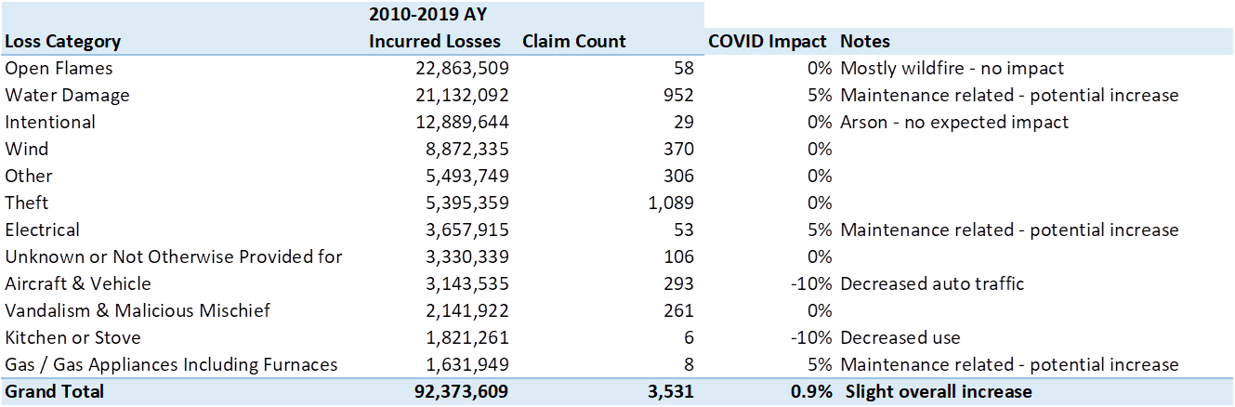
As expected, the property claims we experienced in 2020 were similar in numbers and cost in 2020 as it was in prior years.
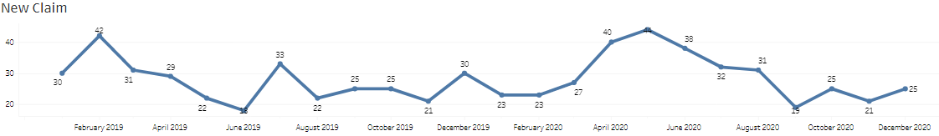
Regarding our non-admitted and Program business, all perils present the same exposure as pre-COVID. We expect a slight increase in exposure similar to those identified in the above chart. In addition, we see no reduced exposure on our earthquake program given the peril.
Commercial Liability – Given the classes of business and the exposure basis used in pricing these risks, GuideOne believes our currently charged premium accurately reflects the risk. The exposure basis on the vast majority of our business is not variable in nature (payroll, receipts, sales, etc.) but rather is square footage. This exposure basis is not impacted as it relates to COVID-19.
We do currently offer three programs which either utilize a different exposure basis or premium audit. However, both of these are considered essential business and retained operations. Our Auto Dealers program utilizes number of employees. However, we have a very limited number of policies and the insured can endorse mid-term to reflect the correct exposure.
GuideOne Oil and Gas program is currently premium audited to reconcile our GL exposure. As noted above, GuideOne has instituted a 60 countrywide grace period for premium payments in which we will not assess late fees or cancel for non-payment. Given the recent guidance following a meeting between APCIA staff and Deputy Commissioner Ken Allen, we will address any premium reduction through the annual audit process as we have already provided premium accommodations through the application of a grace period.
GuideOne Environmental program is an “essential” business through COVID-19. The focus of this program is clean up service providers, i.e. ServiceMaster, ServPro, etc. These business have seen an increase in activity and exposure through COVID-19 as they provide their services.
GuideOne is a predominantly niche writer. As a result, our product offering is tailored to our respective niches. We currently offer many Add On coverages as an endorsement to our General Liability coverage form. The “add-on” coverages include Professional Liability, Employment Practices Liability and Director’ & Officers. These coverages are likely to see an increase in exposure due to COVID-19 as claims materialize.
As a large writer of religious organizations, we believe there continues to be an increase in exposure for as Churches begin to open their doors to services. We continue to see outbreaks traced to church services as the super spreader source. The large gatherings have and will continue to bring greater exposure to loss, losses which we did not contemplate in the rating plan. Given that we write policies on an annual basis and we price accordingly, we expect to continue to see increased exposure now and in the future as California and the country continue to manage the impacts of Covid19. As a result, we believe in totality our Commercial Liability is the same or greater than pre COVID-19 and do not believe a premium adjustment is warranted. We do recognize there were situations where additional exposures such as church camps, church special events, etc. had to be canceled. GuideOne has and will continue to provide premium refunds or have agreed to remove the endorsements as requested by the customer.
Given the above information and our continued efforts to work with our insureds through this very difficult time, please accept this as full compliance with Bulletin 2020-3 and acknowledgement that no further premium adjustments are necessary at this time.

Sincerely,

Jordan Fuehrer J.D., CPCU
Underwriting Compliance Director
Telephone: (877) 448-4331 Ext. 5838
Email: JFuehrer@Guideone.com

Appendix

Premium Breakdown by Line of Business and Niche

Admitted Core Business

LOB | Niche | Sum of Total Premium |  | Count of Policy
BAP | Church | 1,327,186 |  | 1,596
 | Education | 155,070 |  | 36
 | Non-Profit | 477,536 |  | 120
 | Senior Living | 52,649 |  | 17
 | Small Business | 10,798 |  | 5
BAP Total |  | 2,023,239 |  | 1,774
BOP | Church | 427,124 |  | 224
 | Small Business | 304,043 |  | 94
BOP Total |  | 731,167 |  | 318
CPP | Church | 16,473,493 |  | 3,035
 | Education | 578,358 |  | 38
 | Non-Profit | 1,367,975 |  | 144
CPP Total |  | 18,419,826 |  | 3,217
MONO* | Church | 24,823 |  | 31
 | Education | 132,895 |  | 8
 | Non-Profit | 110,579 |  | 51
 | Senior Living | 276,019 |  | 15
MONO* Total |  | 544,316 |  | 105
UMB | Church | 1,074,388 |  | 612
 | Education | 108,865 |  | 20
 | Non-Profit | 326,144 |  | 48
UMB Total |  | 1,509,397 |  | 680
WC | Church | 8,764,770 |  | 1,871
 | Education | 1,713,697 |  | 29
 | Non-Profit | 3,264,189 |  | 74
 | Programs | 6,576,153 |  | 44
 | Senior Living | 7,111,690 |  | 16
 | Small Business | 513,800 |  | 154
WC Total |  | 27,944,301 |  | 2,184
Grand Total |  | 51,172,248 |  | 8,273

*Please note, the vast majority of the MONO referenced above is Monoline Property.

Programs Business

California |  | Auto Liability | APD | GL | Property | Inland Marine | Crime | Excess Liability | Cyber | Equip BD | Terrorism | TOTAL
Admitted Programs
 | Oil & Gas | 4,688,813 | 1,341,387 | 848,787 | 356,340 | 107,506 | 9,582 | 0 | 0 | 0 | 12,184 | 7,364,599
 | Auto Dealers | 433,679 | 88,422 | 231 | 169,455 | 27,416 | 22,751 | 186,581 | 5,554 | 13,658 | 1,546 | 949,283
 | Auto Repossession | 156,181 | 35,415 | 0 | 0 | 3,483 | 0 | 0 | 0 | 0 | 7 | 195,086
 | Residential EQ | 0 | 0 | 0 | 1,482 | 0 | 0 | 0 | 0 | 0 | 0 | 1,482
TOTAL |  | 5,278,673 | 1,465,224 | 849,018 | 527,267 | 138,405 | 32,333 | 186,581 | 5,554 | 13,658 | 13,737 | 8,510,450
Non-Admitted Programs
 | Oil & Gas Excess | 0 | 0 | 0 | 0 | 0 | 0 | 189,904 | 0 | 0 | 0 | 189,904
 | Environmental | 0 | 0 | 1,141,648 | 0 | 0 | 0 | 251,853 | 0 | 0 | 0 | 1,393,501
 | Excess | 0 | 0 | 0 | 0 | 0 | 0 | 10,911,577 | 0 | 0 | 0 | 10,911,577
 | Earthquake | 0 | 0 | 0 | 13,221,044 | 0 | 0 | 0 | 0 | 0 | 0 | 13,221,044
 | Wind | 0 | 0 | 0 | 0 | 0 | 0 | 0 | 0 | 0 | 0 | 0
 | Small Commercial | 0 | 0 | 0 | 0 | 0 | 0 | 0 | 0 | 0 | 0 | 0
 | Specialty Contractors | 0 | 0 | 4,070,398 | 0 | 0 | 0 | 0 | 0 | 0 | 8,800 | 4,079,198
 | Builder’s Risk | 0 | 0 | 0 | 1,772,506 | 0 | 0 | 0 | 0 | 0 | 0 | 1,772,506
TOTAL |  | 0 | 0 | 5,212,046 | 14,993,550 | 0 | 0 | 11,353,334 | 0 | 0 | 8,800 | 31,567,730
TOTAL |  | 5,278,673 | 1,465,224 | 6,061,064 | 15,520,817 | 138,405 | 138,405 | 11,539,915 | 5,554 | 13,658 | 22,537 | 40,078,180

Non-Admitted – Specialty

 | Property
Specialty | 16,515,333

