June 12, 2020

Commissioner Ricardo Lara
California Department of Insurance
300 Capital Mall, 17th Floor
Sacramento, CA 95814

Re: Bulletin 2020-3 – Premium Refunds, Credits, and Reductions in Response to COVID-19 Pandemic
Insurer: GuideOne Mutual Insurance Company
GuideOne Specialty Mutual Insurance Company
GuideOne National Insurance Company
NAIC: 303-15032
303-14559
303-14167

Dear Commissioner Lara:

GuideOne Insurance recognizes the unprecedented nature of the events surrounding COVID-19 and the impact to the people of California. To ensure we provide appropriate accommodations to our policyholders through these difficult times, we instituted a 60 day grace period on cancellations due to non-payment of premium on a countrywide basis. In addition, we are not assessing any late fees or non-sufficient funds fees during this grace period. GuideOne continues to work with our insureds to ensure we are flexible during these unique times. We continue to accept individual requests for those that have suffered a hardship as a result of COVID-19 and offer flexibility and options regarding premium payments.

GuideOne has done a full analysis of our book and we do not believe an overall premium refund is warranted given the classes of business in which we write. Rather, we have chosen to assess any reduced exposures and corresponding premium adjustments on an account by account basis. Given the nature of commercial business and the variance in what is considered “essential business” in the state, we believe this is the appropriate course of action.

GuideOne is a niche insurance carrier with our primary niche focus being Religious Organizations, Education, Non-Profit and Human Services and Senior Living Communities. Given the focus of these niches, the vast majority of our insureds were considered “essential workers”. Given the increased exposure with COVID-19 and the fact that the majority of our insureds were “essential workers” we do not believe any additional premium adjustments beyond those outlined below are warranted.

In accordance with Bulletin 2020-3, we have provided the below information identifying by line of business.

Commercial Automobile
GuideOne is offering insured’s who have ceased the use of their vehicles during the COVID-19 pandemic the opportunity to suspend their coverage. The insured is prorated the return premium for the period of suspension. This would ensure that our insureds recognize the full benefit of their reduced exposure by pro-rating the entirety of their premium for the suspended coverage.
Rather than providing a blanket credit or premium reduction to all insureds, we believe this is the most appropriate action as it addresses the true reduction of exposure while allowing flexibility to our insureds to halt coverage for vehicles not operated during the state’s emergency order.
In addition to our Core Business niches, we write two additional programs. The vast majority of this premium falls in our Oil & Gas Fuel Haulers program. Given the essential nature of this business and their continued operations throughout COVID-19, no premium adjustment is necessary at this time. However, we are offering the option of auto suspensions as well, should any vehicles be out of service.
Finally, given our niche focus and the industry segments we serve, our filed rating plan already contemplates a reduced usage based on the nature of our insureds. Below is a representation of our current Loss Cost, LCM and Rate in relation to ISO. This is consistent across the territories within the state of California and with both School/Church buses and Private Passenger Autos.
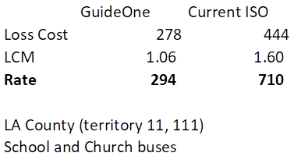
We will continue to work with our insureds on a case by case basis who have seen a significant impact due to COVID-19 and their auto usage.
Workers’ Compensation
A large portion of the GuideOne Workers’ Compensation book of business is in the Senior Living Community space. With the recent passing of Governor Gavin Newsom’s Executive Order N-62-60, which created a rebuttable presumption that an employee’s COVID-19-related illness arose out of the course of employment for purposes of obtaining workers’ compensation benefits, we believe there has been a potentially significant increase in exposure that was not contemplated in our filed rating plan.
In addition, all GuideOne workers’ compensation business is subject to premium audit to reflect accurate payroll and exposure for the policy period.
As noted above, GuideOne has instituted a 60 countrywide grace period for premium payments in which we will not assess late fees or cancel for non-payment. Given the recent guidance following a meeting between APCIA staff and Deputy Commissioner Ken Allen, we will address any premium reduction through the annual audit process as we have already provided premium accommodations through the application of a grace period.
Commercial Multiple Peril
Commercial Property – GuideOne does not believe there has been any reduction in exposure as it relates to commercial property. We have done a By Peril assessment and provide it below. This reflects the anticipated impact of COVID-19 as it relates to our historical property claims.
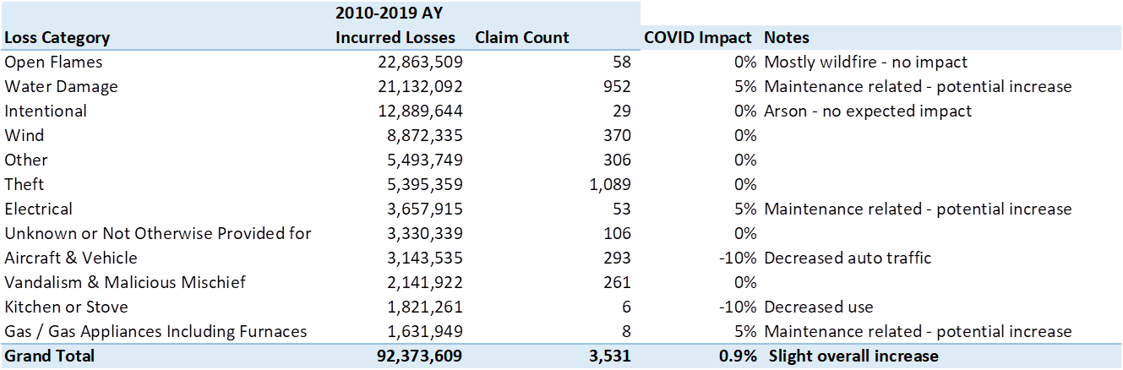
Regarding our non-admitted and Program business, all perils present the same exposure as pre-COVID. We expect a slight increase in exposure similar to those identified in the above chart. In addition, we see no reduced exposure on our earthquake program given the peril.
Commercial Liability – Given the classes of business and the exposure basis used in pricing these risks, GuideOne believes our currently charged premium accurately reflects the risk. The exposure basis on the vast majority of our business is not variable in nature (payroll, receipts, sales, etc.) but rather is square footage. This exposure basis is not impacted as it relates to COVID-19.
We do currently offer three programs which either utilize a different exposure basis or premium audit. However, both of these are considered essential business and retained operations. Our Auto Dealers program utilizes number of employees. However, we have a very limited number of policies and the insured can endorse mid-term to reflect the correct exposure.
GuideOne’s Oil and Gas program is currently premium audited to reconcile our GL exposure. As noted above, GuideOne has instituted a 60 countrywide grace period for premium payments in which we will not assess late fees or cancel for non-payment. Given the recent guidance following a meeting between APCIA staff and Deputy Commissioner Ken Allen, we will address any premium reduction through the annual audit process as we have already provided premium accommodations through the application of a grace period.
GuideOne’s Environmental program is an “essential” business through COVID-19. The focus of this program is clean up service providers, i.e. ServiceMaster, ServPro, etc. These business have seen an increase in activity and exposure through COVID-19 as they provide their services.
In addition to the above, GuideOne is a predominantly niche writer. As a result, our product offering is tailored to our respective niches. We currently offer many Add On coverages as an endorsement to our General Liability coverage form. These Add On coverages include Professional Liability, Employment Practices Liability and Directors & Officers. These coverages are likely to see an increased exposure due to COVID-19 as claims materialize.
Finally, as large writer of religious organizations, we believe we will see an increased in exposure for the coming months as Churches begin to open their doors to services. This is evidenced by the recent event of at least 2 California church services being identified as the sources of outbreaks. These large gatherings will bring greater exposure that is not contemplated in our current rating plan. Given that we write policies on an annual basis and we price accordingly, we expect to increased exposure both prior to the stay at home order and after the re-opening occurs.
As a result, we believe in totality our Commercial Liability is the same or greater than pre COVID-19 and do not believe a premium adjustment is warranted.
Given the above information and our continued efforts to work with our insureds through this very difficult time, please accept this as full compliance with Bulletin 2020-3 and acknowledgement that no further premium adjustments are necessary at this time.

Sincerely,

Jordan Fuehrer J.D., CPCU
Underwriting Compliance Director
Telephone: (877) 448-4331 Ext. 5838
Email: JFuehrer@Guideone.com

Appendix

Premium Breakdown by Line of Business and Niche

Admitted Core Business

LOB | Niche | Sum of Total Premium |  | Count of Policy
BAP | Church | 993,844 |  | 610
 | Education | 170,720 |  | 30
 | Non-Profit | 380,992 |  | 119
 | Senior Living | 212,022 |  | 59
BAP Total |  | 1,757,578 |  | 818
BOP | Church | 119,478 |  | 56
 | Small Business | 490,752 |  | 181
BOP Total |  | 610,230 |  | 237
CPP | Church | 13,457,630 |  | 3151
 | Education | 634,177 |  | 43
 | Non-Profit | 1,162,288 |  | 149
CPP Total |  | 15.254,095 |  | 3343
MONO* | Church | 18,081 |  | 28
 | Education | 170,200 |  | 9
 | Non-Profit | 133,274 |  | 73
 | Senior Living | 1,052,065 |  | 63
MONO* Total |  | 1,373,620 |  | 173
UMB | Church | 842,782 |  | 619
 | Education | 123,669 |  | 23
 | Non-Profit | 259,302 |  | 45
UMB Total |  | 1,225,753 |  | 687
WC | Church | 10,598,619 |  | 2139
 | Education | 1,961,999 |  | 43
 | Non-Profit | 3,405,540 |  | 113
 | Programs | 8,080,776 |  | 50
 | Senior Living | 9,999,641 |  | 41
 | Small Business | 663,361 |  | 157
WC Total |  | 34,709,936 |  | 2543
Grand Total |  | 54,931,212 |  | 7801

*Please note, the vast majority of the MONO referenced above is Monoline Property.

Programs Business

California |  | Auto Liability | APD | GL | Property | Inland Marine | Crime | Excess Liability | Terrorism | TOTAL
Admitted Programs
 | Oil & Gas | 3,330,829 | 1,081,526 | 732,499 | 322,647 | 81,725 | 11,031 | 0 | 8,646 | 5,568,903
 | Auto Dealers | 201,582 | 36,007 | 1,388 | 61,745 | 9,749 | 8,727 | 77,046 | 928 | 397,172
 | Auto Repossesion | 213,762 | 46,981 | 0 | 0 | 5,248 | 0 | 0 | 16 | 266,007
TOTAL |  | 3,746,173 | 1,164,514 | 733,887 | 384,392 | 96,722 | 19,758 | 77,046 | 9,590 | 6,232,082
Non-Admitted Programs
 | Oil & Gas Excess | 0 | 0 | 0 | 0 | 0 | 0 | 13,395 | 0 | 13,395
 | Environmental | 0 | 0 | 909,959 | 0 | 0 | 0 | 201,823 | 0 | 1,111,782
 | Excess | 0 | 0 | 0 | 0 | 0 | 0 | 9,077,411 | 0 | 9,077,411
 | Earthquake | 0 | 0 | 0 | 14,017,373 | 0 | 0 | 0 | 0 | 14,017,373
 | Wind | 0 | 0 | 0 | 0 | 0 | 0 | 0 | 0 | 0
 | Small Commercial | 0 | 0 | 0 | 0 | 0 | 0 | 0 | 0 | 0
TOTAL |  | 0 | 0 | 909,959 | 14,017,373 | 0 | 0 | 9,292,629 | 0 | 24,219,961
TOTAL |  | 3,746,173 | 1,164,514 | 1,643,846 | 14,401,765 | 96,722 | 19,758 | 9,369,675 | 9,590 | 30,452,043

Non-Admitted – Specialty

 | Property
Specialty | 3,404,870

