|  |
| --- |
| Reporting Suspected FraudulentInsurance Claims |
| California Department of Insurance Fraud Division |



|  |  |
| --- | --- |
| * Requirements * Instructions   August 2018 | |
| California Department of Insurance  ENFORCEMENT BRANCH  FRAUD DIVISION  2400 Del Paso Rd., Suite 250  Sacramento, CA 95834  PHONE (916) 854-5760  FAX (916) 854-5848  REGIONAL OFFICES Benicia 1100 Rose Drive, Suite 100  Benicia, CA 94510  (707) 751-2000 Fresno 5737 N. Fresno Street  Fresno, CA 93710  (559) 440-5900 Inland Empire 9674 Archibald Avenue, Suite 100  Rancho Cucamonga, CA 91730  (909) 919-2200 Orange 333 S. Anita Drive, Suite 450  Orange, CA 92868  (714) 712-7600 Sacramento 2400 Del Paso Rd., Suite 250  Sacramento, CA 95834  (916) 854-5700 San Diego 10021 Willow Creek Rd., Suite 100  San Diego, CA 92131  (858) 693-7100 Silicon Valley 18425 Technology Drive  Morgan Hill, CA 95037  (408) 201-8800 Southern Los Angeles County 5999 E. Slauson Avenue  City of Commerce, CA 90040  (323) 278-5000 Valencia 27200 Tourney Road, Suite 375  Valencia, CA 91355  (661) 253-7400 |  | Mission  The mission of the Fraud Division of the California Department of Insurance is to protect the public and prevent economic loss through the detection, investigation, and arrest of insurance fraud offenders.  Every person who reports suspected fraudulent insurance claims to the Fraud Division furthers this mission.  New Badge Stars 2008 | |
|  |  |  | |

Table of Contents

Mission 2

Table of Contents 3

Reporting Requirements 4

Instructions for Completing Form FD-1: 9

Suspected Fraudulent Claim Referral 9

SECTION I. Reporting Party Information 9

SECTION II. Loss/Injury Information 9

SECTION III. Suspected Fraudulent Claim Activity 10

SECTION IV. Reports to Other Agencies 11

SECTION V. Contact Information 11

SECTION VI. Insured/Employer Information (Party A) 11

SECTION VII. Other Parties to the Loss/Injury (Additional Parties) Page 2-3 12

APPENDIX A. Reporting Requirements & Authorities 13

APPENDIX B. Code Listing 14

APPENDIX C. Suspected Fraud Type Code Definitions 16

APPENDIX D. Form FD-1 Suspected Fraudulent Claim Referral 19

|  |  |
| --- | --- |
| Reporting Requirements | |
| Who Must Report | Anyone may report suspected fraudulent insurance claims and premium fraud to the California Department of Insurance (CDI) Fraud Division. All licensed insurers doing business in California and all self-insured employers (for Workers’ Compensation cases only) that suspect fraudulent claim activity must report it. A self-insured’s third-party administrator (TPA) or other contractor shall submit FD-1 referral forms on the self-insured’s behalf. Refer to Appendix A. (see page 13) for detailed requirements and authority cites. |
|  |  |
| What Fraud Must Be Reported | Any suspected fraudulent insurance claim activity victimizing or involving any California insured, insurer, employee and permissibly self-insured shall be reported, regardless of the location where the fraud was allegedly committed. |
|  |  |
| What Information Is Required | The Form FD-1 Suspected Fraudulent Claim (SFC) Referral Form (see pages 6-8 for a sample completed form) requests information about the loss/injury, alleged victim, suspicious fraudulent activity, and names and identifying information of the parties involved. In addition, reporting parties who have made investigative efforts are encouraged to attach additional documentation to the referral. |
|  |  |
| When Must a Report Be Made | **Workers’ Compensation** - 60 days after insurer knows or reasonably believes a fraudulent act was committed (CIC 1877.3 (b)(1) and 1877.3 (d)). Furnished to CDI and District Attorney.  **All others** – 60 days after insurer determines claim appears fraudulent (1872.4 (a)). Furnished to CDI.  **If you have documented results of an investigation that confirm your suspicions of fraud, please immediately contact your Fraud Division Regional Office** in person or by phone to discuss it (see the inside cover and the following page for contact and address information). |
|  |  |
| Immunity from Civil Liability | The California Insurance Code (CIC) contains provisions affording limited immunity from civil liability for insurers and their authorized agents who provide information to the CDI Fraud Division. These provisions do vary. Please reference the language to the applicable provision (CIC Sections §1872.5, 1873.2, 1877.5, 1874.4, 1875.4, 1875.18 and 1876.4). |
| Where to Obtain Additional FD-1 Forms | You may reproduce the 4-page Form FD-1 (see Appendix D., page 19, for a camera-ready version). For additional copies of this booklet, call (916) 854-5760 or write to the address below. The Form FD-1 may also be accessed on the Departments web site, www.insurance.ca.gov. |
|  |  |
| Where to Submit Completed Referral Forms | Completed Form FD-1s should be mailed to the following address:  CDI Fraud Division Intake Unit  2400 Del Paso Rd., Suite 250  Sacramento CA 95834 |
|  |  |

|  |  |  |
| --- | --- | --- |
| How CDI UsesThis Information | FD-1 referrals submitted by insurers, law enforcement agencies, the public and others provide the foundation for the CDI Fraud Division’s anti-fraud program. **The value of accurate, timely and complete referrals cannot be overstated.** Unreported incidents and incomplete and/or inaccurate information on FD-1s impedes CDI’s ability to gather and report intelligence information; match parties to previous fraudulent activity; and effectively evaluate whether to further investigate the circumstances.  On receipt, the Centralized Intake Unit immediately reviews referrals for accuracy and completeness. Within 12 business days, data from incoming FD-1s are entered into the Fraud Division’s Insurance Fraud Information System (IFIS) and the referrals are directed to the appropriate CDI Fraud Division regional office. Investigative staff conduct preliminary intelligence gathering, evaluate the FD-1 information, make a decision about whether to initiate a formal investigation, and notify the reporting party about the action CDI will take. | |
| Getting Help | If you have questions about reporting requirements or need help completing an FD-1 referral form, please contact the CDI Fraud Division regional office which serves your county. | |
|  | **If your California county is—**  Alpine, Amador, Butte, Calaveras, Colusa, El Dorado, Glenn, Lassen, Modoc, Mono, Nevada, Placer, Plumas, Sacramento, San Joaquin, Shasta, Sierra, Siskiyou, Stanislaus, Sutter, Tehama, Trinity, Tuolumne, Yolo, Yuba  Alameda, Contra Costa, Del Norte, Humboldt, Lake, Marin, Mendocino, Napa, San Francisco, Solano, Sonoma  Monterey, San Benito, San Mateo, Santa Clara, Santa Cruz  Fresno, Inyo, Kern, Kings, Madera, Mariposa, Merced, San Luis Obispo, Tulare  Southern Los Angeles and the City of Los Angeles Metropolitan Area  Northern Los Angeles including the San Fernando Valley, Santa Barbara, Ventura  Orange  Riverside, San Bernardino  Imperial, San Diego | **Your Regional Office is—**  Sacramento (916) 854-5700  Benicia (707) 751-2000  Silicon Valley (408) 201-8800  Fresno (559) 440-5900  Southern Los Angeles County  (323) 278-5000  Valencia (661) 253-7400  Orange (714) 712-7600  Inland Empire (909) 919-2200  San Diego (858) 693-7100 |
|  |  | |
|  | **If you are calling from another state or country** and are unsure which Regional Office to contact, please call our Fraud Division headquarters in Sacramento at (916) 854-5760. | |
|  |  | |

Sample of Completed Form FD-1 (Page 1)

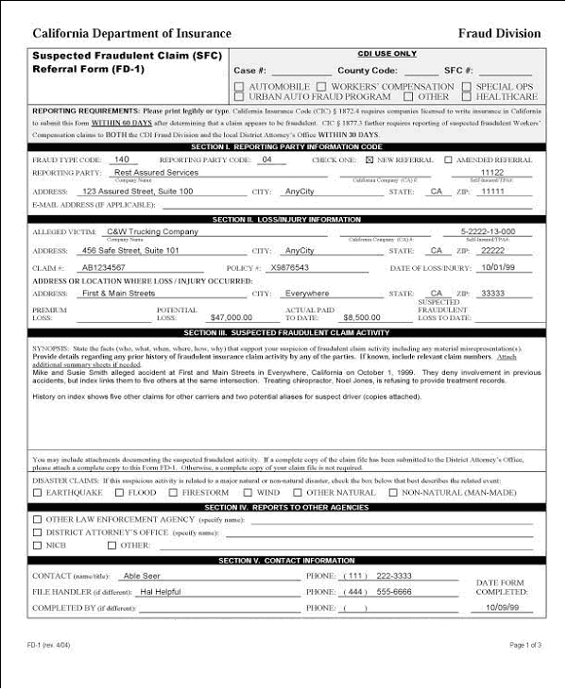

Sample of Completed Form FD-1 (Page 2)

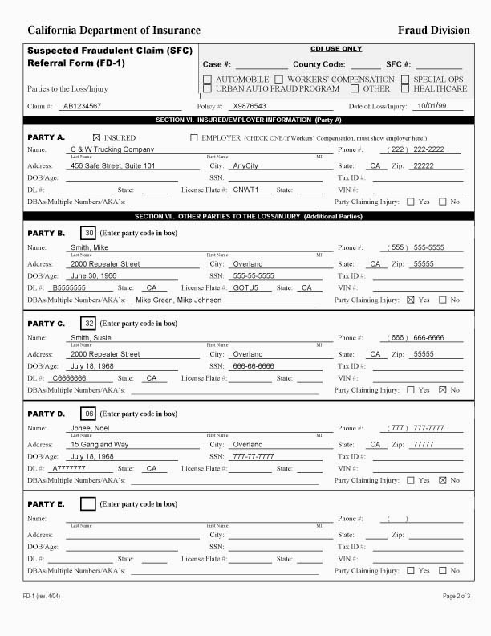Sample of Completed Form FD-1 (Page 3)

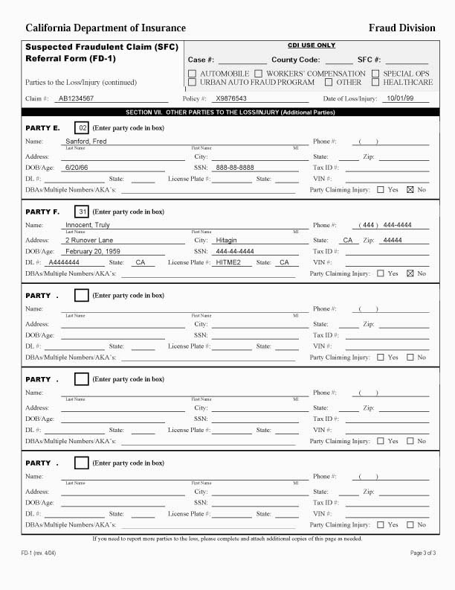

|  |  |
| --- | --- |
| Instructions for Completing Form FD-1:  Suspected Fraudulent Claim Referral | |
| SECTION I. Reporting Party Information | |
| Using The FD-1 Form Via Computer | This form was created in Microsoft Word 97. It is recommended that you use the **“Tab”** key to navigate between fields and not the “Enter” key when using the FD-1 form on your computer. |
|  |  |
| Fraud Type Code | Enter the most appropriate Suspected Fraud Type code. For a list of codes, refer to Appendix B. Code Listing (see page 14-15). If you are unsure which code to use, refer to Appendix C. Code Definitions (see pages 16–18). |
|  |  |
| Reporting Party Code | Enter the most appropriate Reporting Party code. For a list of codes, refer to Appendix B. Code Listing (see page 16-18). If you are a third-party administrator (TPA) or other contractor, select, from codes 1, 2, 3, or 4, the code that best describes the nature of the insurer for which you are working. |
|  |  |
| New Referral/Amended ReferralCheck One: | Check the “New Referral” box if this is the first referral you have made for this incident of suspected fraud. Check the “Amended Referral” box if you have previously reported this incident and are adding, deleting or correcting information you previously provided. |
|  |  |
| Reporting Party | To ensure proper identification, enter the full and complete company name of the reporting carrier, self-insured, TPA, law enforcement agency, or other entity/individual making the referral. To ensure proper identification, **do not** use acronyms or initials unless they are part of the formal name. |
|  |  |
| California Company (CA) # | If you are an insurer authorized to transact business in California, enter your CDI-assigned California Company (CA) number. |
|  |  |
| Self-Insured #/TPA# | If you are a Third Party Administrator (TPA), enter the TPA number assigned by the California Department of Industrial Relations. If you are self-insured, enter one of the following: self-insured number assigned by either the California Department of Industrial Relations or California Department of Motor Vehicles. |
|  |  |
| Address/City/ State/ZIP/E-mail | Enter your mailing address and e-mail address (if applicable). |
|  |  |
| SECTION II. Loss/Injury Information | |
| Alleged Victim | Enter the full and complete company name of the insurance carrier or self-insured that you suspect is being victimized. In the case of an employer defrauding an employee (Suspected Fraud Type Code 510), enter the name of the employee whom you suspect is being victimized. To ensure proper identification, **do not** use acronyms or initials unless they are part of the formal name. |
|  |  |
| California Company (CA) # | If the alleged victim is an insurer licensed to transact business in California, enter the CDI-assigned California Company (CA) number. |
|  |  |
| Self-Insured #/TPA# | If the “Alleged Victim” is self-insured, enter one of the following: self-insured number assigned by either the California Department of Industrial Relations or California Department of Motor Vehicles, or TPA number assigned by the California Department of Industrial Relations. |
|  |  |

|  |  |  |
| --- | --- | --- |
| Claim Number | Enter the claim number issued by the insurer. For amended referrals, be sure to include the identical claim number as originally reported on the initial referral. | |
|  |  | |
| Policy Number | Enter the policy number issued by the insurer. For amended referrals, be sure to include the identical policy number as originally reported on the initial referral. | |
|  |  | |
| PremiumDollar Loss | **For premium fraud cases only** (Suspected Fraud Type Code 561 (Misclassification), 562 (Under-Reported Wages), or 563 (X-Mod Evasion)), enter the potential loss in total premium dollars if the fraud had gone undiscovered. Otherwise, leave blank. | |
|  |  | |
| Location Of Loss/Injury | Indicate the name of the city, state and zip code where the loss or injury is alleged to have occurred. If the specific address is not known, please note such details as the intersection, mall name, or other location identifying information. NOTE: The accuracy of this information is critical, as it will determine which CDI Fraud Division regional office is assigned to handle the case. | |
|  |  | |
| Date of Loss/Injury | Enter the reported date of loss or injury. If more than one date has been reported for the loss or injury, enter the earliest alleged date. | |
|  |  | |
| Potential Loss | Enter the potential dollar loss/exposure for this claim if the fraud had gone undiscovered. | |
|  |  | |
| Actual Paid to Date | Enter the total dollar amount paid on the claim as of the referral date. Include amounts you suspect to be fraudulent as well as those that may be legitimate. For premium fraud cases (Suspected Fraud Type Code 561 (Misclassification), 562 (Under-Reported Wages), or 563 (X-Mod Evasion)), leave this field blank. | |
|  |  | |
| Suspected Fraudulent Loss To Date | Of the amount you reported on the “Actual Paid to Date” line, enter the dollar amount you suspect to be fraudulent. | |
|  |  | |
| SECTION III. Suspected Fraudulent Claim Activity | | |
| Synopsis | | State the facts that support your suspicion(s) of fraudulent insurance claim or premium fraud activity. Detail the material misrepresentation(s) made by the parties. Be specific and concise. Include information addressing the basic questions: who, what, when, where, why, how much and how often. **Attach additional summary sheets if needed to complete the synopsis.** |
|  | |  |
|  | | Examples:   * ***Suspected Fraud Type Code 140 (Auto Collision/Right-of-Way****): Accident appears staged. Suspect driver and passenger deny involvement in any previous accidents, but Index links them to 5 others including an earlier incident (7/23/98) at this same location. Treating chiropractor is refusing to provide medical records.* * ***Suspected Fraud Type Code 500 (Workers’ Compensation/Claimant Fraud)****: Doctor reports claimant malingering. Claimant maintains he cannot walk. Sub Rosa video on day of medical appointment shows claimant faking inability to walk; on video, claimant runs and walks normally.* * ***Suspected Fraud Type Code 561 (Workers’ Compensation/Premium Fraud****): Suspect misclassification of workers’ hourly rates to avoid premium costs.* |
|  | |  |
|  | | **In all cases, provide any known details, of each party’s history of involvement in fraudulent insurance claims**.  Examples:   * *Insured has reported four other claims in last two years including: XYZ Company, Claim #122321/ABC Insurer, loss dates 7/23/98, 9/19/97 and 8/24/98.* * *Index shows 5 hits on similar names, three of which are for the same address as the insured (copies attached).* * *NICB shows several previous claims involving the suspect driver and passenger.* |

|  |  |
| --- | --- |
| Disaster-Related Activity | Check the box if suspected fraudulent claim activity is related to a **major** disaster, i.e., a disaster that has produced a gubernatorial or presidential declaration of emergency. Indicate the type of disaster to which the activity is related: natural (earthquake, flood, firestorm, wind or other natural disaster) or non-natural (civil unrest, chemical spills, airborne contamination, etc.). |
|  |  |
| Attachments | Attach any documentation you have of investigative efforts you have completed. If you are submitting a complete copy of the claim file to the District Attorney, reciprocate by including a complete copy with this referral to CDI. |
|  |  |
| SECTION IV. Reports to Other Agencies | |
| Other Law Enforcement Agency | Check this box if you have reported this suspected fraudulent claim to any other law enforcement agency and enter the specific name of the agency to which this suspected fraudulent claim was referred. |
|  |  |
| District Attorney’s Office | Check this box if you have reported this suspected fraudulent claim to any District Attorney’s Office (required for workers’ compensation claims under CIC 1877.3(b)(1)), and enter the name of the county served by the District Attorney’s office to which the claim was referred. |
|  |  |
| NICB | Check this box if you have reported this suspected fraudulent claim to the National Insurance Crime Bureau (NICB). |
|  |  |
| Other | Check this box if you have reported this suspected fraudulent claim to any other agency and enter the specific name of the agency to which the claim was referred. |
|  |  |
| SECTION V. Contact Information | |
| Contact | Enter the name, title and telephone number of the person who should be contacted by a CDI investigator(s) needing additional information relative to the claim. |
|  |  |
| File Handler | If different from the contact person listed previously, enter the name and phone number of the file handler (the adjuster/claims representative assigned to the claim who can provide requested information and documentation). |
|  |  |
| Completed By | Enter the name and phone number of the person completing the Form FD-1, if different from both the contact person and file handler. Enter this information in the format of First Name, Middle Initial and Last Name. |
|  |  |
| Date Form Completed | Indicate the date form was completed. |
|  |  |
| SECTION VI. Insured/Employer Information (Party A) | |
| Claim/Policy Number | Enter the claim and policy numbers you reported on the first page of the FD-1. If you are submitting an amended referral, these numbers should be identical to those originally reported on the initial referral. |
|  |  |
| Date of Loss/Injury | Enter the date of loss/injury you reported on page 1 of the FD-1. |
| Insured/Employer Check Box | **The employer must be listed in the Party A section for any Workers’ Compensation fraudulent claim referral.** If you are reporting a suspicious workers’ compensation claim, check the employer box. Otherwise, check whichever box is appropriate. |
|  |  |
| Name | **The employer must be listed in the Party A section for any Workers’ Compensation fraudulent claim referral.** If you are reporting a suspicious workers’ compensation claim, enter the name of the employer. Otherwise, enter the appropriate name. |
|  |  |

|  |  |
| --- | --- |
| Party Claiming Injury | Check the “yes” box if Party A is claiming to be injured or believed to have died as a result of the situation being reported. Otherwise, check the “no” box. When an injury/death is being claimed, check the “yes” box regardless of whether you believe the injury/death to be real. |
|  |  |
| Additional Instructions | Include all of the requested information if you know it. When providing AKAs, include all nicknames, monikers, maiden names and other aliases. On the “DBAs/Multiple#s/AKAs” line, provide any company name(s) under which Party A is “doing business as” (DBA) as well as additional nicknames, monikers, maiden names and/or other aliases, dates of birth, social security or other numbers Party A may be using, e.g., DBA XYZ and Company; SSN 444-44-4444; DL A0123456. |
|  |  |
| SECTION VII. Other Parties to the Loss/Injury (Additional Parties) Page 2-3 | |
| Instructions | Make a separate entry for every other party to the loss/injury**. Be sure to enter the appropriate Party Code in the box** (for a list of party codes, refer to the Appendix B. Code Listing, pages 12-13). As you did for Party A, enter all other requested information known about the party, including whether or not he/she claims to be injured. On the “DBAs/Multiple#s/AKAs” line, provide any company name(s) under which Party is “doing business as” (DBA) as well as additional nicknames, monikers, maiden names and/or aliases, dates of birth, social security or other numbers Party B may be using, e.g., DBA XYZ and Company; SSN 444-44-4444; DL A0123456. |
|  |  |
| Claim/Policy Number | Enter the claim and policy numbers you reported on the first page of the FD-1. If you are submitting an amended referral, these numbers should be identical to those originally reported on the initial referral. |
|  |  |
| Date of Loss/Injury | Enter the date of loss/injury you reported on page 1 of the FD-1. |
|  |  |
| Page 3 Parties to the Loss Continued | You may copy this page as needed to report additional parties to the loss/injury. |
|  |  |

APPENDIX A. Reporting Requirements & Authorities

|  |  |  |  |  |
| --- | --- | --- | --- | --- |
| If your agency is: | You are required to submit: | Within the following time frame | | Authority |
| * A company licensed to write insurance in California | A separate FD-1 Referral Form for every suspected fraudulent claim | * For workers’ compensation claims , within 60 days of knowing or reasonably believing a claim to be fraudulent * For any other type of suspected fraudulent claim, within 60 days of determining that a claim appears to be fraudulent | | CIC §1872.4(a)  CIC §1877.3(d)  CIC §1872.85 |
| * An insurer admitted to transact workers’ compensation insurance in California * The State Compensation Insurance Fund * An employer that has secured a certificate of consent to self-insure pursuant to Section 3700 (b) or (c) of the Labor Code * A third-party administrator that has secured a certificate pursuant to Section 3702.1 of the Labor Code | A separate FD-1 Referral Form for each suspected fraudulent Workers’ Compensation claim | Within 60 days of knowing or reasonably believing a person or entity has committed a fraudulent act relating to a workers’ compensation claim | | CIC §1877.1(c)  CIC §1877.3(b)  CIC §1877.3(c)  CIC §1877.3(d)  CIC §1872.85 |
| * Any California police, sheriff, disciplinary body governed by the provisions of the Business and Professions Code, or any California law enforcement agency | All papers, documents, reports, complaints, or other facts or evidence CDI requests. | None specified in law | | CIC §1872.4(d)  CIC §1872.85 |
|  | * This is a reciprocal arrangement; CDI is required by law to furnish the same information when requested by any police, sheriff or other law enforcement agency * CDI encourages these agencies to submit FD-1 Referral forms for all cases involving suspected insurance fraud * CDI further encourages these agencies to call the appropriate regional office to request deployment of CDI investigators to the scene of any suspected staged automobile accident | | | |
| * California Departments of Highway Patrol, Motor Vehicles, and Justice * Any California city or county law enforcement agency * Any California city or county agency employing peace officers as designated in Penal Code Sections 830.1 (a) and (b); 830.2 (a); and 830.3 (b), (d), (k) * Any other California law enforcement agency * Any licensing agency governed by the Business and Professions Code | Any or all information released to or received from an insurer or authorized agent of an insurer relating to any specific insurance fraud, except for motor vehicle fraud and workers’ compensation fraud must also be submitted to CDI | Within 10 days of receipt of the information from the insurer or agent | CIC §1873.4  CIC §1872.85 | |

APPENDIX B. Code Listing

* This listing contains codes for the three fields on the Form FD-1 that require them: Suspected Fraud Type, Reporting Party, and Party to the Loss.
* Detailed definitions for Suspected Fraud Type is included in Appendix C. (refer to pages 14-16). Code names assigned to the other two fields are self-explanatory.
* Establishing new codes for this revision of the Form FD-1, while maintaining the historical integrity of CDI’s database, required leaving the majority of the original codes and their meanings intact. You will also notice that “other” codes, which are found at the end of a list, are numerically out of sequence. We apologize for any inconvenience this may cause.

|  |  |  |
| --- | --- | --- |
| APPENDIX B. Code Listing | | |
| |  | | --- | | Suspected Fraud Type Code |   Auto Collision  Swoop & Squat 100  Sudden Stop 110  Backing 120  Pedestrian vs. Auto 130  Right of Way 140  Phantom Vehicle 150  Hit & Run 160  Paper Collision 170  Organized Ring 180  Medical Provider 190  Auto Property  Faked Damages 200  Inflated Damages 210  Vehicle Theft 220  Vehicle Arson 230  Auto Property / Vandalism 240  Agent / Broker 250  Embezzlement 260  Trailered Watercraft / Theft 270  Damage  Trailered Watercraft Arson 280  Other Auto Property 290  Medical  Slip & Fall 300  Inflated Billing 320  Disability 330  Food Contamination 340  Pharmacy 350  Dental 360  Embezzlement 370  Other Medical 310  Life  Questionable Death 400  Suspicious/False Policy 420  Application  Other Life 410  Workers’ Compensation  Claimant Fraud 500  Employer Defrauding Employee 510  Legal Provider 520 Medical Provider 530  Pharmacy 540  Misclassification 561  Under-Reported Wages 562  X-Mod Evasion 563  Embezzlement 570  Uninsured Employer 580  Other Workers’ Compensation 550 | Miscellaneous  Casualty 600  Agricultural / Livestock 610  Fire  Commercial Fire 700  Arson for Hire 710  Residential Fire 720  Inflated Fire Loss 730  Property  Theft – Residential 800  Theft – Commercial 810  Theft – Commercial Carrier 820  Watercraft / Aircraft Theft 830  Watercraft / Aircraft Arson 840  Vandalism 860  Property Theft From Vehicle 870  Agent / Broker 880 Other Property Damage 850 Mold Related 890  Healthcare  Embezzlement 001  Identify Theft 002  Unlawful Solicitation/Referral 003  Billing Fraud 004  Immunization Fraud 005  Other Healthcare 006  Pharmacy 007  Surgery Center Fraud 008  Disability 009   |  | | --- | | Reporting Party Code |   Carrier / Licensed Insurer 01  Private Sector Self-Insured 02  Public Sector Self-Insured 03  Third Party Administrator 04  State Fund (SCIF) 05  District Attorney’s Office 06  Law Enforcement Agency 07  Incoming CDI Hotline Call 08  (CDI Use Only)  Other CDI Information Source 09  (CDI Use Only)  Other Reporting Party 10   |  | | --- | | Party To The Loss/Injury Code |   General  Insured 00  Claimant 01  Witness 02  Alias/Also Known As (AKA) 04  Interpreter 13  Continued in next column | General (Cont’d)  Employer 15  Claims Adjuster 16  Agent / Broker 20  Other 09  Medical/Healthcare  Medical Clinic 03  Medical Doctor 05  Chiropractor 06  Psychologist 11  Physical Therapist 12  Osteopath 17  Physician’s Assistant 18  Nurse Practitioner 19  Clinic Administrator 22  Dentist 23  Medical Management 24  Company  Vocational Rehab Counselor 25  Pharmacy / Pharmacist 26  Laboratory 27  Other Medical 28  Surgery Centers 35  Diagnostic / Imaging Centers 36  Pain Management Clinics 37  Cosmetic Surgery Centers 38  Legal  Attorney 07  Law Firm 10  Legal Administrator 14  Paralegal 26  Auto  Suspect Driver 30  Victim Driver 31  Suspect Passenger 32  Suspect Pedestrian 33  Body Shop 08  Repair Shop / Mechanic 34  Capper 21  Workers’ Compensation  Autobody-Premium Fraud 40  Contractor 41  Employee Leasing 42  Janitorial 43  Manufacturing 44  Other Services 45  Professional Employment 46  Agency  Professionals 47  Restaurant/Bar 48  Retail 49  Temp. Agency 51  Transportation 54 |

APPENDIX C. Suspected Fraud Type Code Definitions

Auto Collision

A staged auto collision is defined as a planned incident designed to fraudulently obtain monies from an insurance entity. A planned incident may take on various forms:

100 “Swoop” vehicle swerves in front of “squat” vehicle causing “squat” vehicle to slam on its brakes, which causes a rear-end collision with the victims vehicle.

110 “Squat” vehicle slows down to close gap between his vehicle and victim’s vehicle, then brakes suddenly causing a rear-end collision with victim.

120 Victim’s vehicle collides with suspect’s vehicle while backing out of a driveway or while backing out of a parking space in a parking lot.

130 Pedestrian versus auto.

140 Suspect driver appears to give right-of-way to victim driver, usually in an intersection, causing vehicles to collide; suspect later claims no right-of-way was offered.

150 Solo vehicle crashes due to vehicle of unknown origin/description.

160 “Hit and run” vehicle strikes victim’s car and leaves scene of the accident.

170 Parties conspire to create illusion of legitimate accident, using either pre-damaged vehicles or by intentionally and covertly inflicting damage on the suspect’s vehicle(s). Generally, law enforcement is not called to the scene of the accident.

180 Collision orchestrated by organized criminal activity involving attorneys, doctors, other medical professionals, office administrators and/or cappers.

190 Medical provider inflates billing, knowingly submits bills with improper medical codes, and misrepresents facts.

Auto Property

200 Damages to vehicle exaggerated, non-existent, pre-existing, or vehicle damaged at a later point in time.

210 Damages inflated or exaggerated, non-existent or pre-existing; excessive billing of vehicle body parts or repair work.

220 Vehicle or motor home theft.

230 Vehicle or motor home arson.

240 Vehicle or motor home vandalism including such items as car rims, stereo equipment, and engine parts.

250 Policy backdated prior to loss date and/or theft of premium dollars intended for payment of coverage.

260 Embezzlement of funds.

270 Watercraft stolen or damaged while being transported on trailer.

280 Arson of a watercraft while transported on trailer.

290 Any other auto-related circumstance not listed above involving the presentation of false documents as proof of insurance.

Medical

300 Suspicious slip/fall claim.

310 Non-auto injury reported by insured and/or claimant; medical assistance was reported.

320 Inflated billing by any medical facility, doctor, chiropractor, laboratory, etc.

330 Disability claim submitted against disability insurance policy while claimant on permanent or temporary disability and receiving continual benefits and/or vocational benefits and/or claimant reported working or performing activities exceeding alleged physical limitations.

340 Foreign object found within food/drink products.

350 Pharmacist or pharmacy inflates bills or falsifies billing; person illegally obtains medical prescriptions and submits prescriptions for habitual need.

360 Dentist or dental office inflates bills or falsifies billing codes.

370 Embezzlement of funds.

Life

400 Questionable circumstances surrounding reported death; staged death/false identity.

410 Other life insurance claim-related fraud not described by other Life category code.

420 Suspicious or questionable actions by applicant or policyholder (insured’s health misrepresented on application; suspicious timing of application in relation to insured’s death); potential for monetary gain from life insurance policy. Include suspicious claims involving murder for profit and claims pertaining to viatical settlements.

Workers’ Compensation

500 Suspicious employee applicant claim.

510 Employer committing illegal act against employee(s).

520 Legal provider inflates billing or materially misrepresents the facts.

530 Medical provider inflates billing, knowingly submits bills with improper medical codes, and misrepresents facts.

540 Pharmacy inflates bills or falsifies codes.

550 Any situation dealing with a Workers’ Compensation claim that is not described by any other Workers’ Compensation category code.

561 Misclassifying the type of workers to obtain workers’ compensation coverage at a lower premium. (Example: classifying roofers as clerical, etc.)

562 Misrepresenting payroll to obtain workers’ compensation coverage at a lower premium. (Example: Over-reporting wages as if employees are experienced journeyman with less likelihood of injury and thus allowing for lower premiums or under-reporting payroll to keep premiums lower.)

563 Misrepresenting claims history by not reporting reportable injuries or by creating shell companies to give the impression of a non or low claims history to obtain workers’ compensation coverage at a lower premium.

570 Embezzlement of funds.

580 Uninsured Employers.

Other

600 Casualty, injury or theft that does not pertain to other fraud code definitions.

610 Suspicious loss or damage incurred to agricultural products and/or livestock not caused by acts of nature.

Fire

700 Suspicious commercial/business fire damage.

710 Suspected arson for hire.

720 Suspicious residential fire damage.

730 Inflated claims from fire loss.

Property

800 Suspicious residential theft.

810 Suspicious commercial business theft.

820 Insured reports baggage/cargo lost by commercial carrier (airline, bus, train, vessel).

830 Theft or damage to watercraft/aircraft while not on a trailer.

840 Arson of watercraft/aircraft while not on a trailer.

850 Property damage not included in other definitions.

860 Vandalism or malicious mischief to the interior or exterior of business or residence.

870 Suspicious theft of personal property while stored in a vehicle or motor home (commonly claimed under a homeowner’s insurance policy).

880 Policy backdated prior to loss date and/or theft of premium dollars intended for payment of coverage.

890 Mold related.

Healthcare

001 Embezzlement of funds.

002 Using another’s identity to secure health care benefits.

003 Medical provider knowingly submits false medical bills by billing for services not rendered, billing for wrong procedure codes, or billing for procedures of a medical necessity when procedures may have been elective or cosmetic in nature and not covered by health insurance.

004 Denotes cases where patients are recruited and given incentives to undergo medical procedures, whether those procedures were actually performed or not.

005 False billings by medical providers for immunizations that were not given.

006 Any other health care related circumstances not listed above or covered by another category code.

007 Pharmacy.

008 Surgery Center Fraud

009 Disability

APPENDIX D. Form FD-1 Suspected Fraudulent Claim Referral

* The next page is reference information only. Do not include with submitted referral. Use it to assist in correctly coding Pages 19-21, but **do not include page 18** when reporting to CDI.
* The final three pages contain a camera-ready version of the Form FD-1 suitable for offset printing or photocopying. This is used to report suspected fraudulent claims. **Please submit single sided copies only.**

|  |  |  |
| --- | --- | --- |
| Code Listing and Fraud Division Regional Offices | | |
| |  | | --- | | Suspected Fraud Type Code |   Auto Collision  Swoop & Squat 100  Sudden Stop 110  Backing 120  Pedestrian vs. Auto 130  Right of Way 140  Phantom Vehicle 150  Hit & Run 160  Paper Collision 170  Organized Ring 180  Medical Provider 190  Auto Property  Faked Damages 200  Inflated Damages 210  Vehicle Theft 220  Vehicle Arson 230  Auto Property / Vandalism 240  Agent / Broker 250  Embezzlement 260  Trailered Watercraft / Theft Damage 270  Trailered Watercraft Arson 280  Other Auto Property 290  Medical  Slip & Fall 300  Inflated Billing 320  Disability 330  Food Contamination 340  Pharmacy 350  Dental 360  Embezzlement 370  Other Medical 310  Life  Questionable Death 400  Suspicious/False Policy Application 420  Other Life 410  Workers’ Compensation  Claimant Fraud 500  Employer Defrauding Employee 510  Legal Provider 520 Medical Provider 530  Pharmacy 540  Misclassification 561  Under-Reported Wages 562  X-Mod Evasion 563  Embezzlement 570  Uninsured Employer 580  Other Workers’ Compensation 550 | Miscellaneous  Casualty 600  Agricultural / Livestock 610  Fire  Commercial Fire 700  Arson for Hire 710  Residential Fire 720  Inflated Fire Loss 730  Property  Theft – Residential 800  Theft – Commercial 810  Theft – Commercial Carrier 820  Watercraft / Aircraft Theft 830  Watercraft / Aircraft Arson 840  Vandalism 860  Property Theft From Vehicle 870  Agent / Broker 880 Other Property Damage 850 Mold Related 890  Healthcare  Embezzlement 001  Identify Theft 002  Unlawful Solicitation/Referral 003  Billing Fraud 004  Immunization Fraud 005  Other Healthcare 006  Pharmacy 007  Surgery Center Fraud 008  Disability 009   |  | | --- | | Reporting Party Code |   Carrier / Licensed Insurer 01  Private Sector Self-Insured 02  Public Sector Self-Insured 03  Third Party Administrator 04  State Fund (SCIF) 05  District Attorney’s Office 06  Law Enforcement Agency 07  Incoming CDI Hotline Call 08  (CDI Use Only)  Other CDI Information Source 09  (CDI Use Only)  Other Reporting Party 10   |  | | --- | | Party To The Loss/ Injury Code |   General  Insured 00  Claimant 01  Witness 02  Alias/Also Known As (AKA) 04  Continued in next column | General (Cont’d)  Interpreter 13  Employer 15  Claims Adjuster 16  Agent / Broker 20  Other 09  Medical/Healthcare  Medical Clinic 03  Medical Doctor 05  Chiropractor 06  Psychologist 11  Physical Therapist 12  Osteopath 17  Physician’s Assistant 18  Nurse Practitioner 19  Clinic Administrator 22  Dentist 23  Medical Management Company 24  Vocational Rehab Counselor 25  Pharmacy / Pharmacist 26  Laboratory 27  Other Medical 28  Surgery Centers 35  Diagnostic / Imaging Centers 36  Pain Management Clinics 37  Cosmetic Surgery Centers 38  Legal  Attorney 07  Law Firm 10  Legal Administrator 14  Paralegal 26  Auto  Suspect Driver 30  Victim Driver 31  Suspect Passenger 32  Suspect Pedestrian 33  Body Shop 08  Repair Shop / Mechanic 34  Capper 21  Workers’ Compensation  Autobody-Premium Fraud 40  Contractor 41  Employee Leasing 42  Janitorial 43  Manufacturing 44  Other Services 45  Professional Employment Agency 46  Professionals 47  Restaurant/Bar 48  Retail 49  Temp. Agency 51  Transportation 54 |

|  |  |  |  |
| --- | --- | --- | --- |
| QUESTIONS? Call the Fraud Division Regional Office in your county---- | | | |
| Alpine, Amador, Butte, Calaveras Colusa, El Dorado, Glenn, Lassen, Modoc, Mono, Nevada, Placer, Plumas, Sacramento, San Joaquin, Shasta, Sierra, Siskiyou, Stanislaus, Sutter, Tehama, Trinity, Tuolumne, Yolo, Yuba | Sacramento | (916) 854-5700 |  |
| Alameda, Contra Costa, Del Norte, Humboldt, Lake, Marin, Mendocino, Napa, San Francisco, Solano, Sonoma | Benicia | (707) 751-2000 |  |
| Monterey, San Benito, San Mateo, Santa Clara, Santa Cruz | Silicon Valley | (408) 201-8800 |  |
| Fresno, Inyo, Kern, Kings, Madera, Mariposa, Merced, San Luis Obispo, Tulare | Fresno | (559) 440-5900 |  |
| Southern Los Angeles and the City of Los Angeles Metropolitan Area | Southern Los Angeles County | (323) 278-5000 |  |
| Northern Los Angeles including the San Fernando Valley, Santa Barbara, Ventura | Valencia | (661) 253-7400 |  |
| Orange | Orange | (714) 712-7600 |  |
| Riverside, San Bernardino | Inland Empire | (909) 919-2200 |  |
| Imperial, San Diego | San Diego | (858) 693-7100 |  |
|  |  |  |  |